Dalton Murray

Systems Analysis and Design

INT 6123 – Systems Analysis and Design

Dr. Andrew Makar

December 10, 2023

**IA #14 Test Case Development**

**Question 2 - Assume that you and three of your classmates are charged with developing the first prototype to implement the RMO use case Create/update customer account. Create a development and testing plan to write and test the classes and methods. Assume that you have two weeks to complete all tasks.**

The Create/update customer account has the following information provided in the book:

“Use case: Create/update customer account

User/actor: Customer, phone or store sales representative

Domain classes: Customer, account, address

Events: Customer request or sale to a new customer”

(Satzinger et al., 2016. p. 209).

The book also has:

“Use case: Create customer account

Brief use case description: User/actor enters new customer account data, and the system assigns account number, creates a customer record, and creates an account record.”

(Satzinger et al., 2016. p. 81).

Based upon these two things from the book is what I will create my 5 test cases upon. Given I also only have two weeks to complete these tests I have chosen the start date is 12/04/2023 and the end date is 12/15/2023.

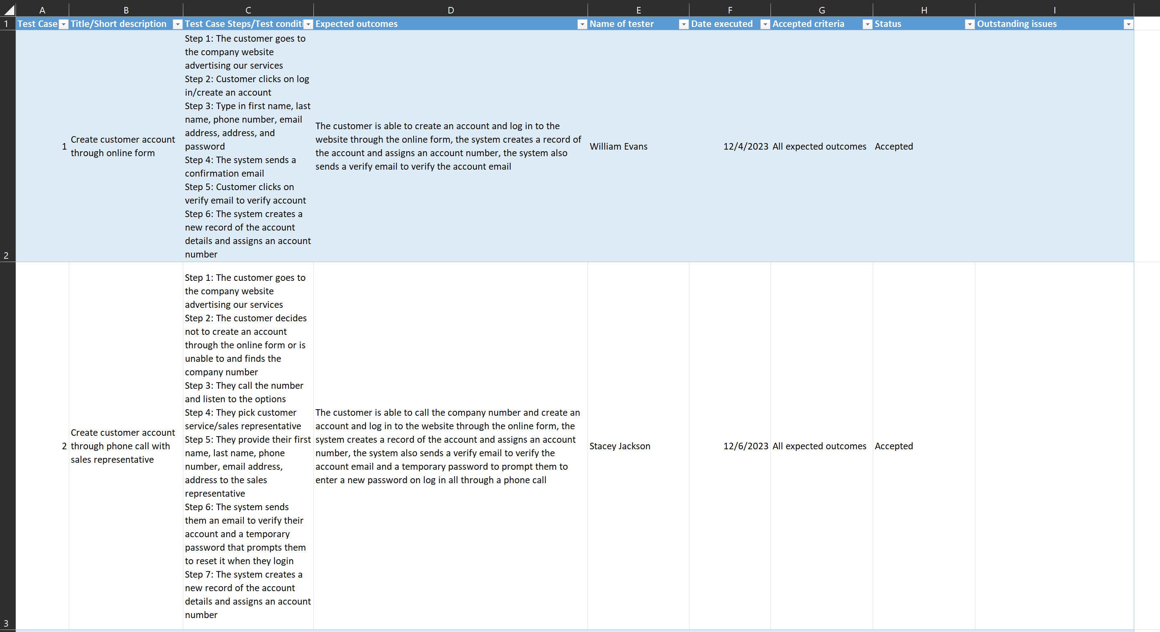

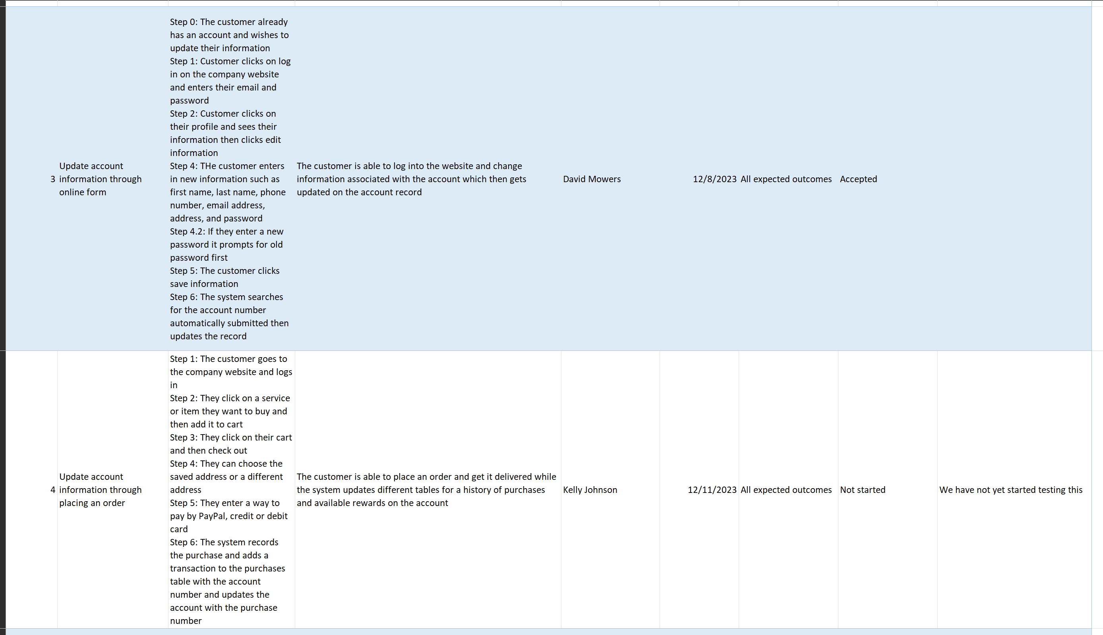

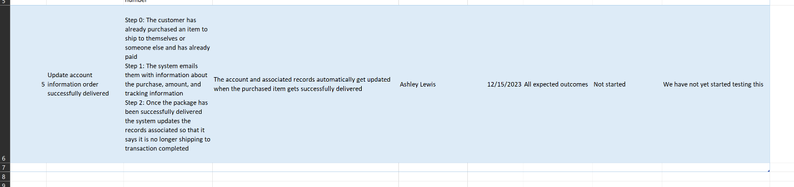

XLSX: Attached separately.

**References**

Satzinger, J. W., Jackson, R. B., & Burd, S. D. (2016). Systems analysis and design in a Changing World (7e ed.). Cengage Learning.

I have neither given nor received unauthorized aid in completing this work, nor have I presented someone else's work as my own.

*Dalton Murray*